Tool to identify the obsolete Calculated Key-Figure (CKF) / Restricted Key-figure (RKF)

Version 1.0

Document Control Section
Authors

Role | Name
SAP Technical Consultant | Gopala Konanki

Reviewers

Role | Name
SAP BW Team Lead | Priti Bhagat

Document History
Version | Author | Reason for change | Date
1.0 | Gopala Konanki | Initial Draft | 12-Dec-2019

General Information:
The Utility allows the user to identify and download the Obsolete CKF/RKFs from the system using the program.
Program Name: ZBXB_TB_CHECK_CKFRKF_QUERIES
T-code: ZBXB_IN_CKFRKF
- Selection Screen
The selection screen is as below.
The utility is capable of two types for selections.
- Input Info-provider to process - where in user can provide the Info-provider for identifying the obsolete CKF/RKF data.
- CSV file Upload – User can upload a excel consisting of the Program name and Variant names
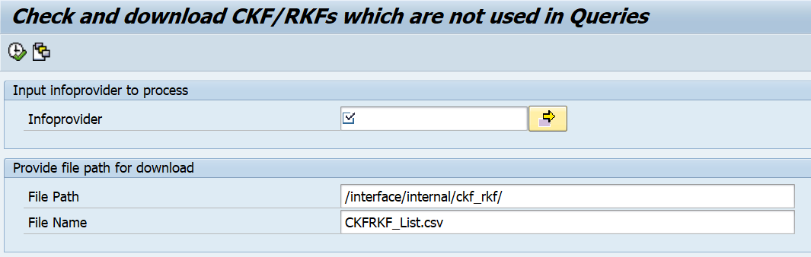

- Functionality
- Execute the program - ZBXB_TB_CHECK_CKFRKF_QUERIES and
Provide Info-provider:
Provide File Path and File Name:
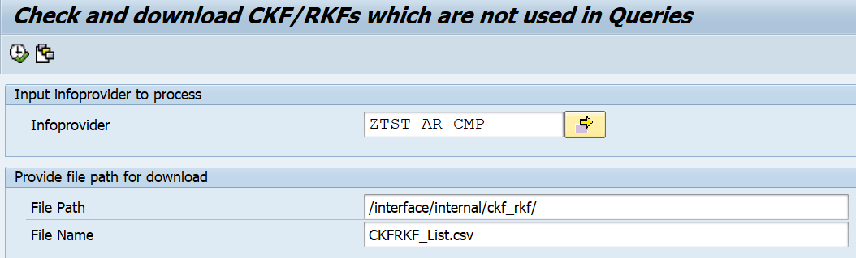

Output: Obsolete CKF/RKF file with date and timestamp will be generated in
Application server.
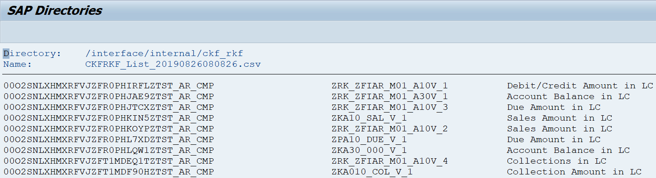
2. The Output file can be used for Deletion of CKF/RKF decision making.
3. For Deletion of Obsolete CKF/RKF, We need to Copy the technical name from first column of output file and run the deletion transaction – RSZDELETE
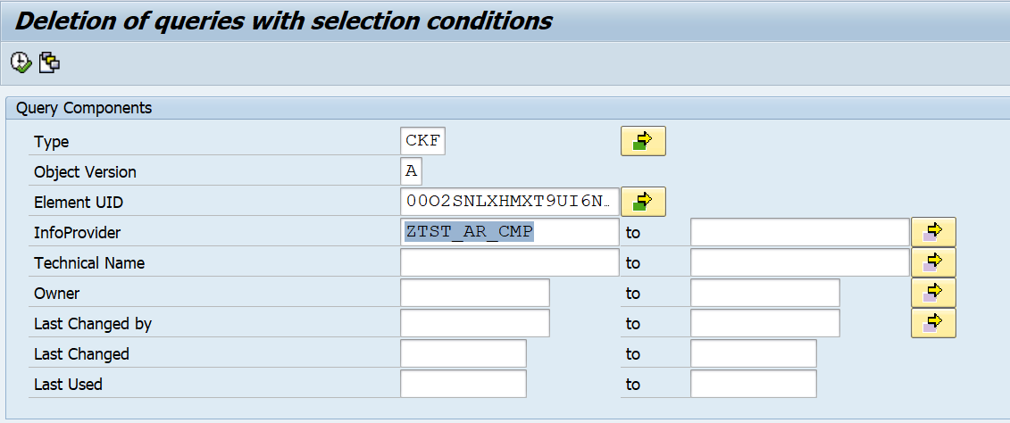
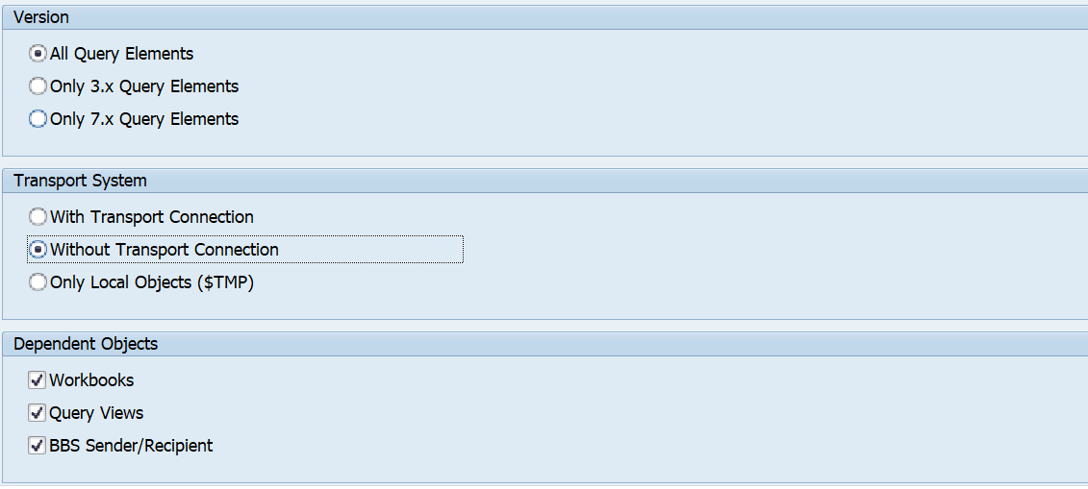
Type: CKF/ SEL (Calculated Key-figure/Restricted Key-figure)
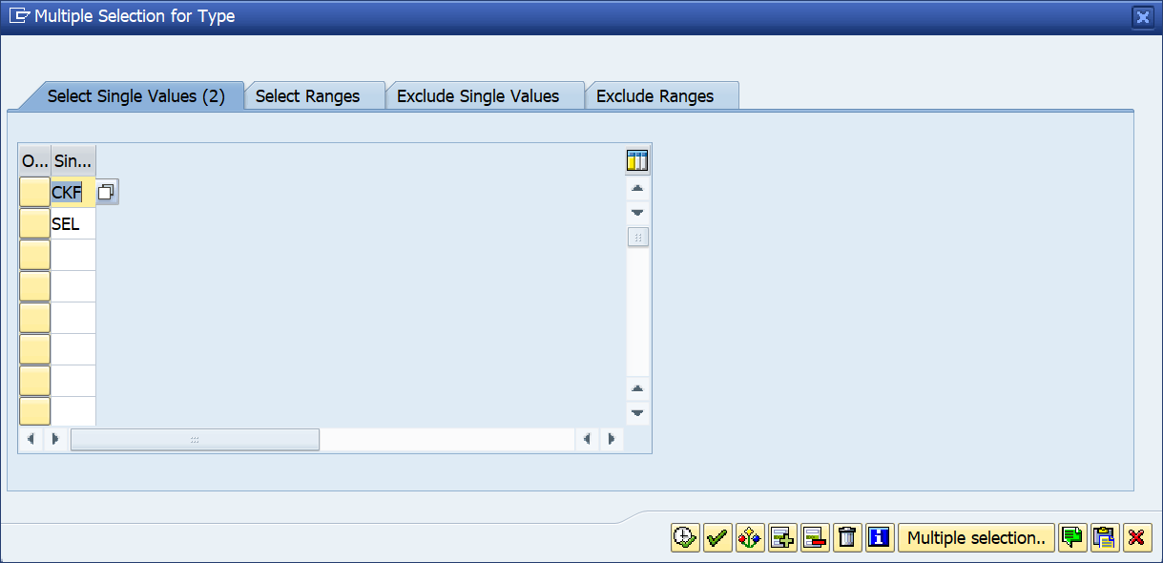
Element ID: Technical name of CKF/RKF
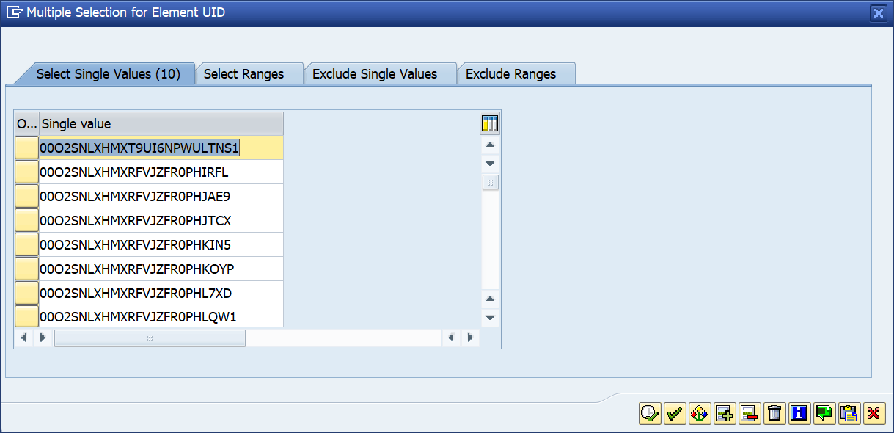

Note: Need to repeat the above steps until we see empty file generated in Application server and ensure no further obsolete CKF/RKFs available for deletion.

